**Practical 4**

**Output :-**

The following simulation has 7 hosts

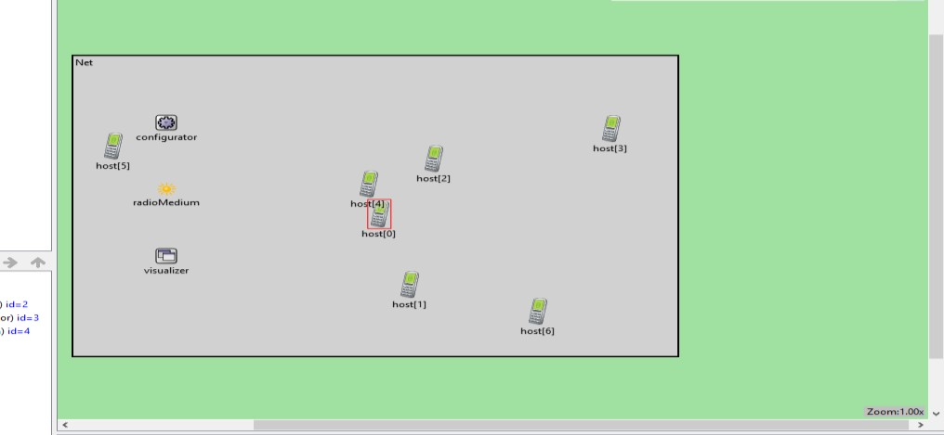

**Practical 5**

**Output :-**

The following command is executed in the CLI mode of Router1

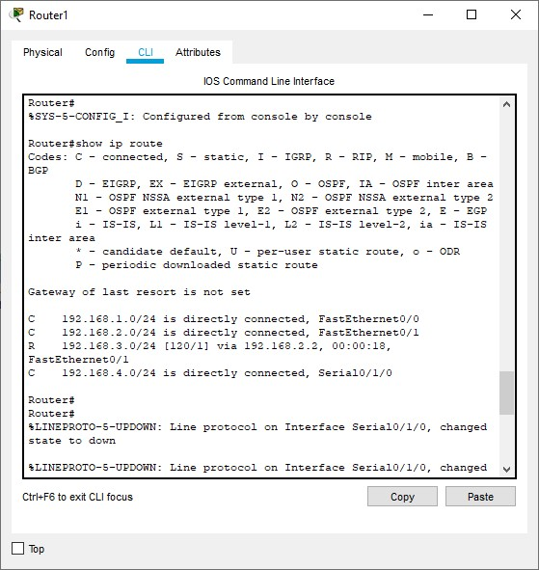

**Practical 6**

**Output :-**

Since the nodes have mobility, after sometime their positions would change and we get

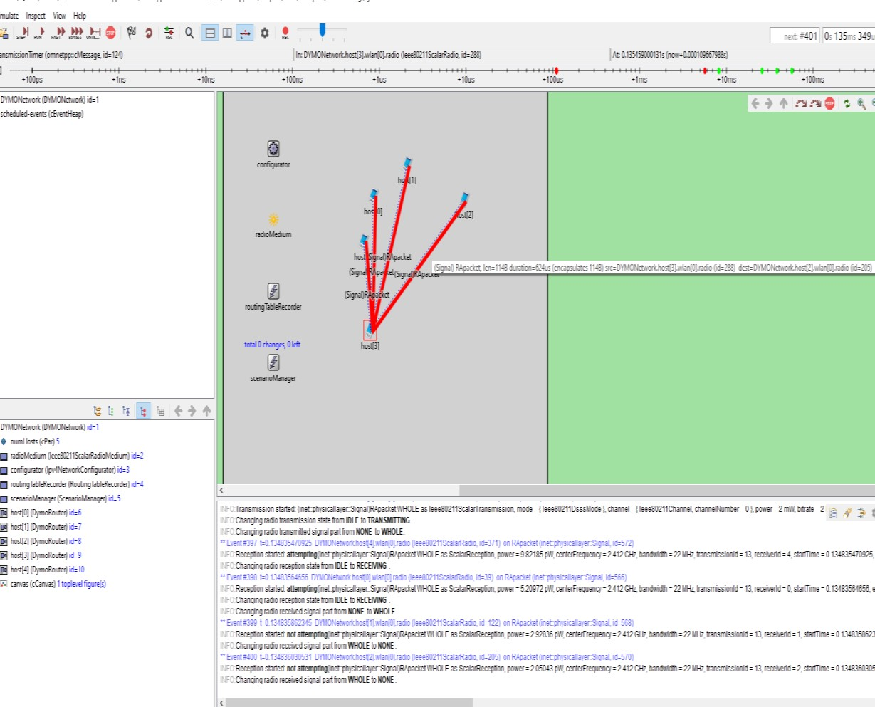

Hence the given MANET has been simulated with 5 hosts

**Practical 7**

**Output :-**

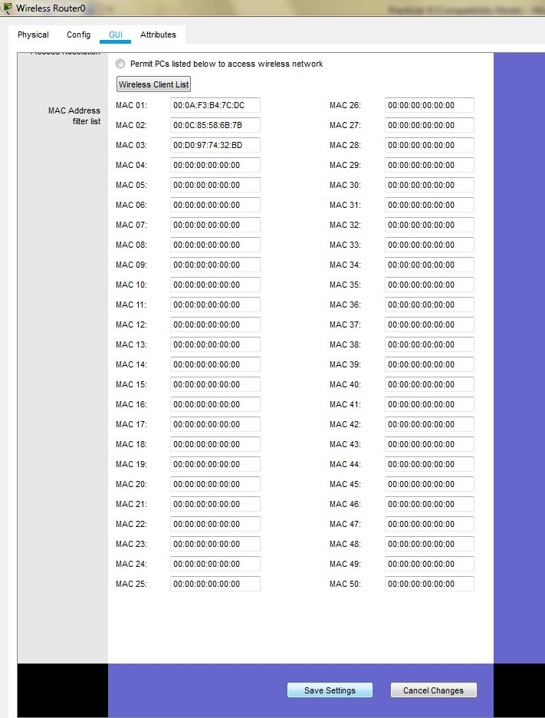

**The result so obtained is as shown; the three devices denied any wireless connectivity**

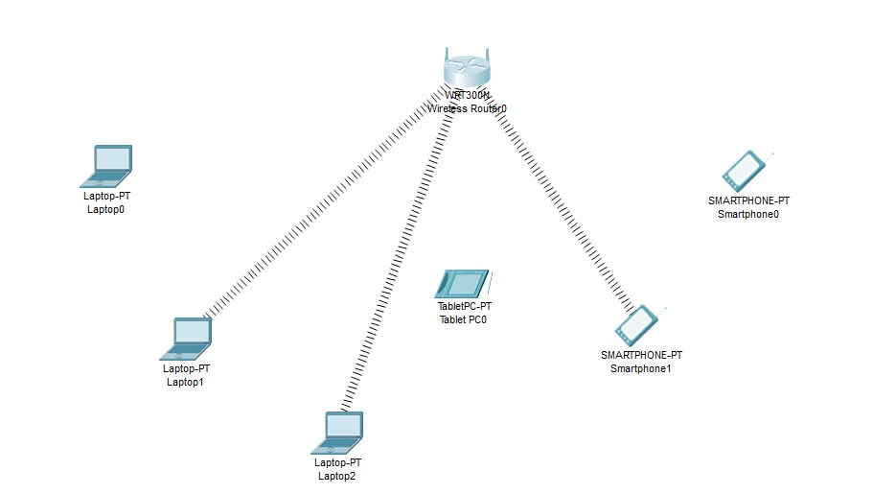

**Output :-**

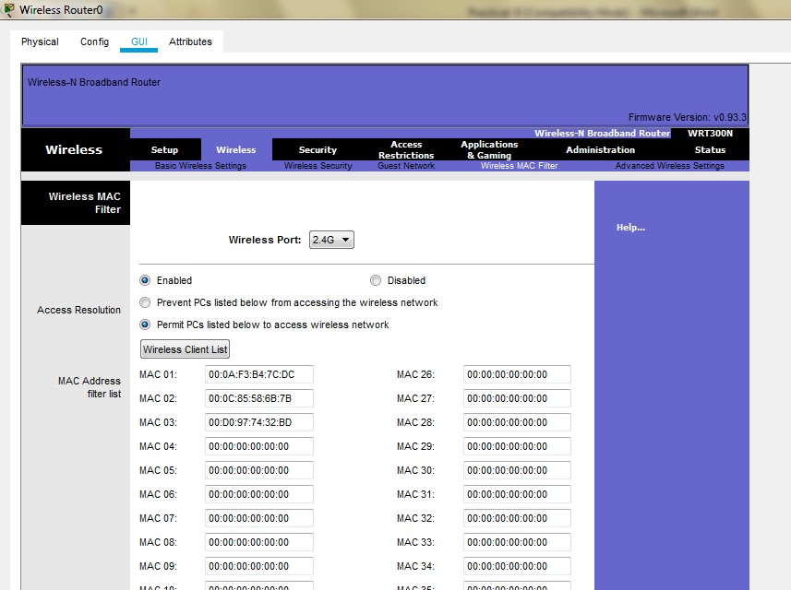

**And save the setting and get the following**

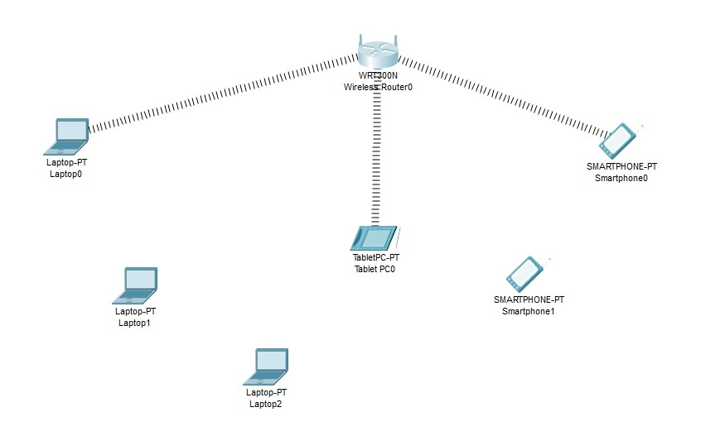

**Practical 8**

**Output :-**

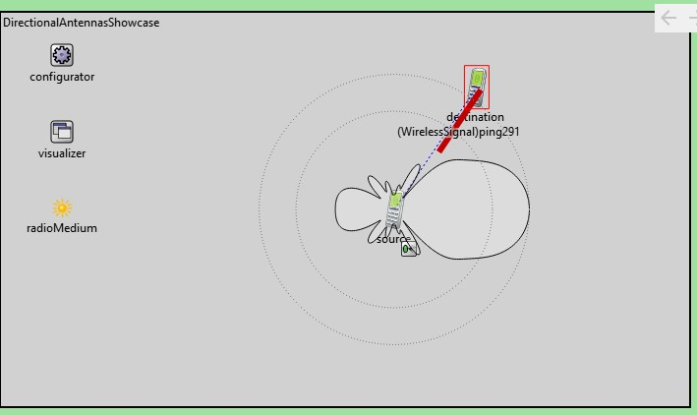

**Practical 9**

**Output :-**

1. Send a ping message from smartphone to server

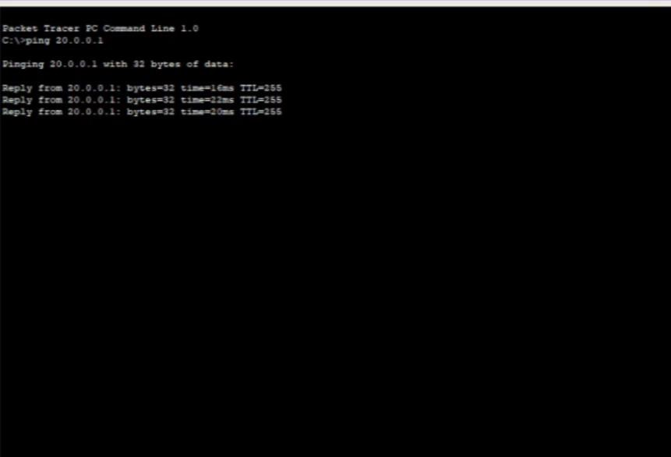

1. Access the web service from the server through the Smartphone

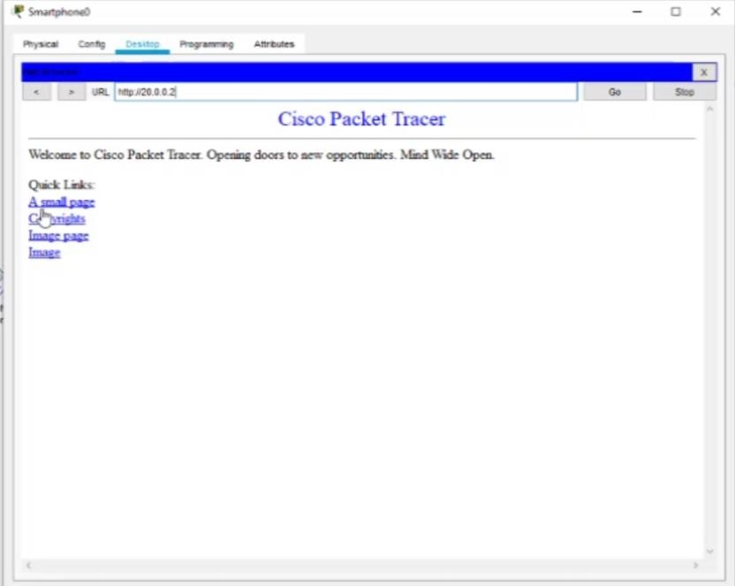

Hence the mobile network was created and connectivity was also verified